
Student Name: ____________________________

Applications – Unit 2 - 2019

Investigation 4 (U2 Inv 2) – Piecewise and Step Functions

Task weighting: 5% (U2 10%) This investigation is in two parts

Part A Take home – This section is completed for homework and is a preparation activity for the
validation. (0 marks)

Part B Validation - 50 minutes in class, under test conditions, that will test your understanding
of the preparation activities in Part A. Calculator ONLY is permitted. (37 marks)
____________________________________________________________________________

Question 1
Ida parks her car at 8.00 am at the university where parking costs $1.50 per hour. She leaves there at 10 am and arrives at the airport at 10:45 am where she parks the car for an hour at $4 per hour. She then drives to the city, arriving at 12.15 pm and parks on the Esplanade at a cost of $4.50 per hour for 2 hours. She then leaves the city and drives home, arriving there at 3.00 pm.

Use the axes below to graph the amount Ida pays for parking from 8.00 am to 3.00 pm.
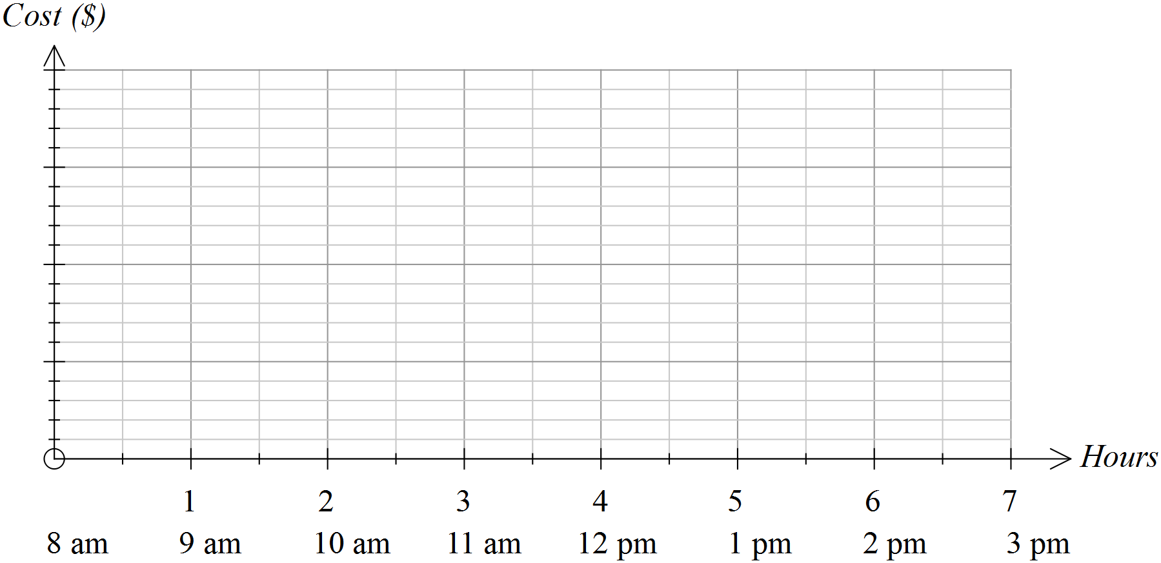

Question 2
The cost of parking at the airport for up to 5 hours is summarised in the table. Show these costs on the axes provided.

First 15 mins | Over 15 mins  Up to 30 mins | Over 30 mins  Up to 1 hour | Over 1 hour  Up to 2 hours | After 2 hours it is an extra $2 per hour or part thereof
Free | $5 | $8 | $12 | After 2 hours it is an extra $2 per hour or part thereof
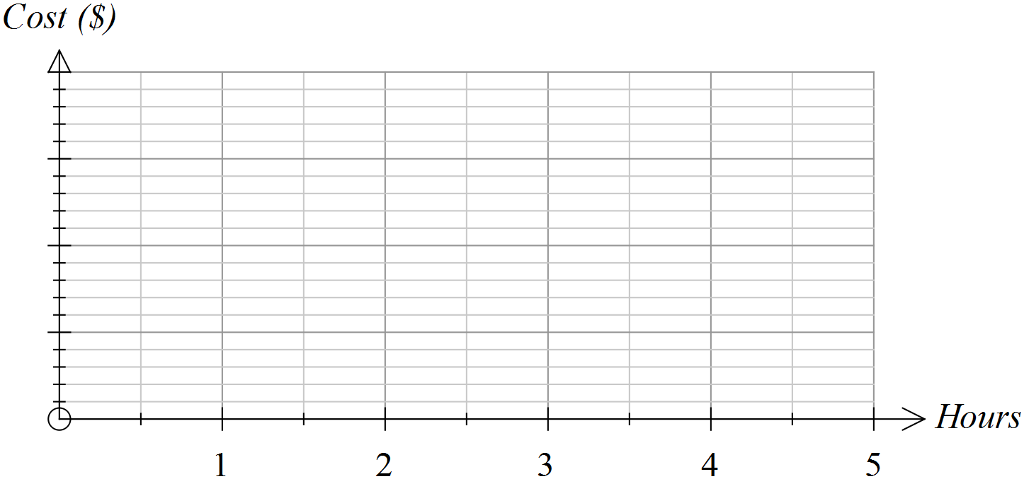

Question 3
The costs of sending parcels of varying weights by post are represented in the graph below.
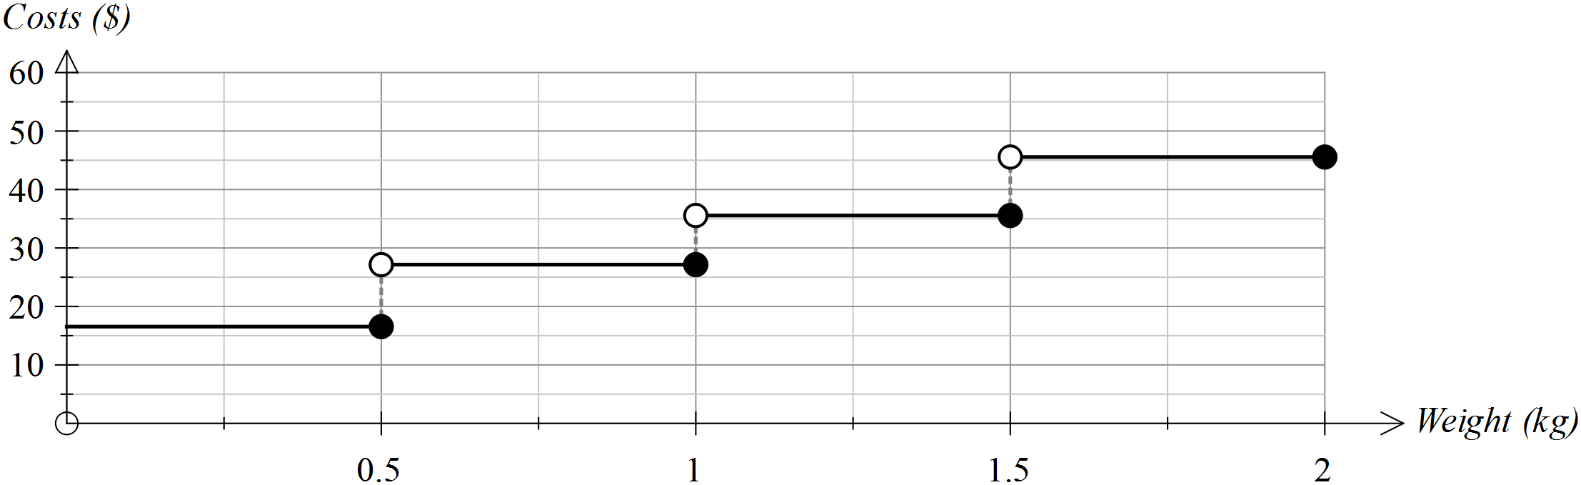

Use the graph to answer the following questions.
(a) What is the approximate cost of sending a parcel weighing 500 g?
(b) What is the approximate cost of sending a parcel weighing 120 g?

(c) If you had $40 to spend on the postage of one parcel, what is the
maximum weight that the parcel could be?
(d) If you were told that your parcel would probably cost less than $30,
what might its weight be?

(e) A decision was made to lower the costs by $10 in each weight range. Draw the graph showing these lowered costs on the graph drawn ABOVE.

(f) A decision was made to lower the costs by 50% in each weight range. Draw the graph showing these lowered costs on the graph drawn BELOW.

Question 4
Tom and Mary were driving in a car rally last week. The time taken to return to their starting point is shown in the graph below.
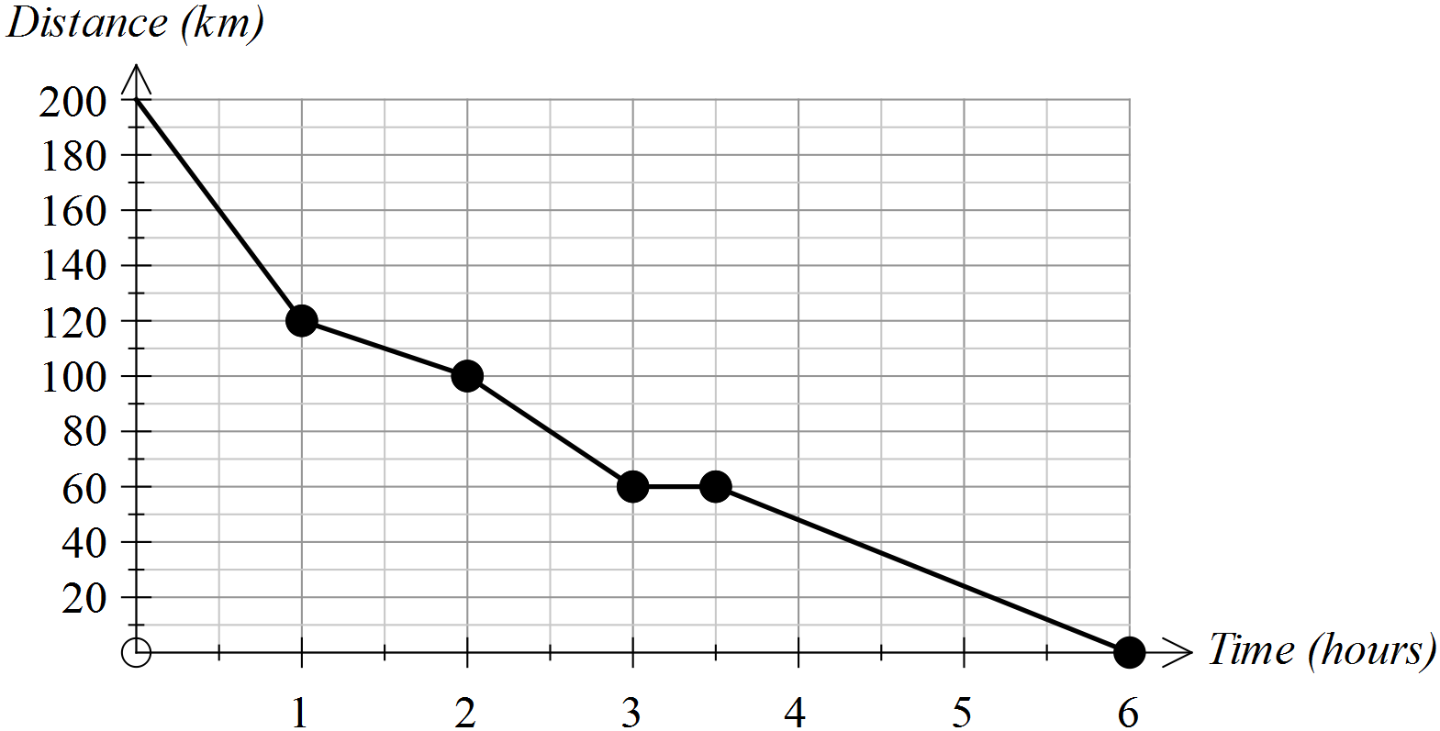

(a) How far was the return journey? _______________

(b) How long did the return journey take? _______________
(c) During which hour did Tom and Mary average the highest speed? How did you determine this answer from
the graph?

(d) For how long did Tom and Mary stop? _______________
(e) At what average speed were Tom and Mary travelling during the last hour of their journey? Show how you determined your answer.
(f) Tom and Mary started their return journey at 6.00 am.
(i) How far had they travelled by 8.30 am? _______________

(ii) Add a segment to this graph to indicate that Tom and Mary could have travelled at a constant speed between 9.00 am and 11.00 am.

End of questions

